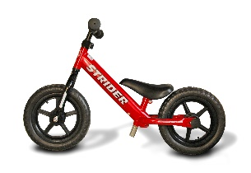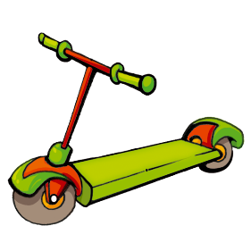

**Pedal Power**

We would like to do some fundraising and what better way than a sponsored bike ride!!

The bike ride will take place during the sessions and be run by the staff. We will set up an assault course on the lower playground and the children can take it in turns during the week to complete the course on their bike / scooter. This will be in conjunction with our healthy lives’ week. Showing the importance of how to keep healthy and fit.

We have bikes of all abilities so all the children can take part. They don’t need to be able to ride a bike to take part, we have bikes that the children can scoot along with their feet. Feel free to bring your child’s bike in or maybe a scooter if that’s what your child prefers, just make sure you have named them in some way so we can ensure that they get returned to the correct children.

When the children have returned their sponsor forms and money, we will have an awards ceremony and all the children that have taken part will receive a certificate and medal.

All you need to do is collect as many sponsors as you can!!! Any amount however big or small will be appreciated and will go into our fundraising fund for activities during the year.

If you require any further information, then please talk to your child’s key person. We will plan to do the bike ride during the week of **Monday 5th October—Friday 9th October** there will be no set times or days but we will ensure that all children get to take part, so bring your bike/scooter along on your session days, you might even get to do it more than once :)

Please return your child’s sponsor form when you have collected all your sponsor’s and we will keep hold of them until they do their bike ride so we can sign it to say they have done it, we will then return them to you so you can go and collect your sponsors.

Good luck, and we look forward to having fun with you on your bikes/scooters!!!